Access to Health Records Request Form Template
This form may be provided to individuals wishing to request data relating to the Health data of deceased individuals, this form should encourage the applicant to provide all the information needed to process the request.
Template:

APPLICATION FOR ACCESS TO HEALTH RECORDS FOR A DECEASED PATIENT
Section 1: Details of Applicant
Surname |  | Postcode
Forename |  | Mobile
Email Address |  | Preferred contact method
Home Address |  | Relationship to Deceased

Section 2: Grounds for Request
The Access to Health Records Act (AHRA, 1990) provides the right to access a deceased person’s health records, you may also request access to health records of a deceased person outside of the AHRA (1990) in certain circumstances. Please specify below your grounds for requesting the data detailed:
 | Please tick if appropriate | Further Detail
I am acting as a representative of the deceased (i.e. Executor or administrator of the deceased person’s estate) (AHRA,1990) |  | N/A
I have a claim arising from the deceased person’s death and wish to access information that is relevant to my claim. |  | Further detail of this claim should be provided here:
Other: |  | Please provide further detail of your grounds for requesting this data:

Section 3: Deceased Patients Details
Surname |  | Postcode
Forename |  | Date of Birth
Address |  | NHS Number (if known)

Section 4: Records Requested
Please use this section to detail what records you are requesting. You may wish to consider the following:
- Whether you intend to request records that relate to a specific illness or condition
- Whether you intend to request records that relate to a certain period of time
In some instances, we may not be able to provide you with all the information that you have requested, where this is the case you will be provided with a full explanation via your preferred contact method.

Section 5: Proof of Identity
To help us verify your request please provide a copy of any relevant document that provides the following:
- Confirmation that you are a personal representative of the deceased (i.e. an executor or administrator of the deceased’s estate (if applicable)
- Evidence that you have a claim about the death of the individual to which this application relates (if applicable)
- Evidence that you have other legal grounds for requesting this data (if applicable)
- Proof of name (see Appendix 1 for acceptable documentation)
- Proof of Address (see Appendix 1 for acceptable documentation)
Please specify what documents you have provided to support this request:

We kindly ask that you do not supply us with original copies of these documents as we cannot assume responsibility for their safety.
Section 6: Declaration
I declare that the information given is correct to the best of my knowledge and that I am entitled to apply for access to the health records referred to within this application form.

Signature:

Date:

You are advised that the making of false or misleading statements to obtain personal information to which you are not entitled is a criminal offence which could lead to prosecution.
Assuming that we have sufficient information to proceed, we will aim to comply with your request in 40 days.
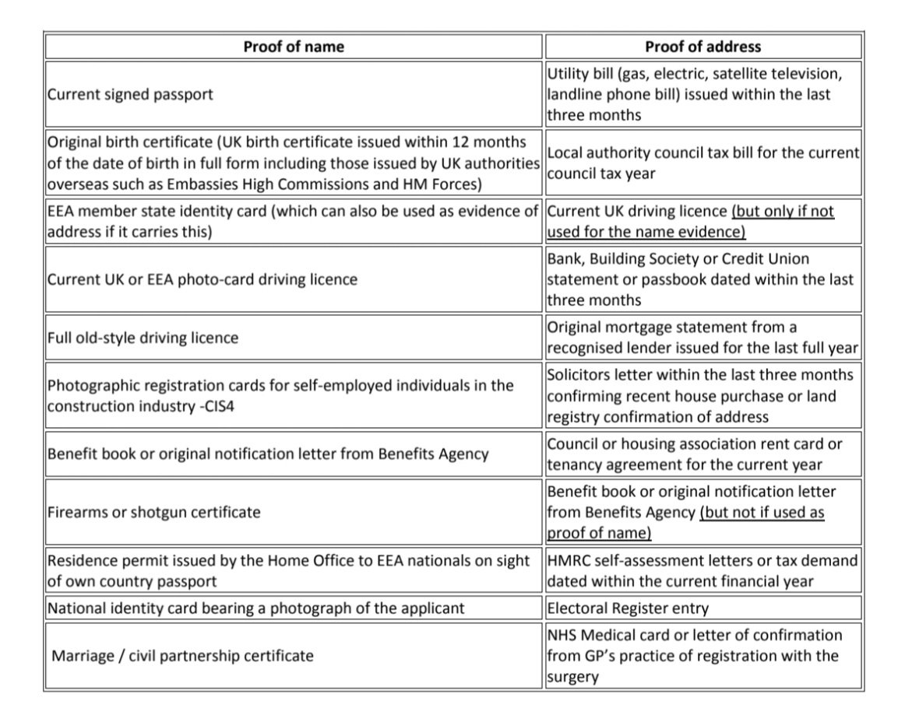
Appendix 1: Acceptable documents for the verification of name and address

